Ideation Phase
Empathize & Discover

Date | 14 July 2026
Team ID
Project Name | SHOPEZ: E-commerce Application
Maximum Marks | 4 Marks

Empathy Map Canvas:
An empathy map is a visual tool used to understand the needs, behaviours, thoughts, and emotions of users. It helps the development team analyse the customer's perspective and identify the challenges they face while interacting with the application.
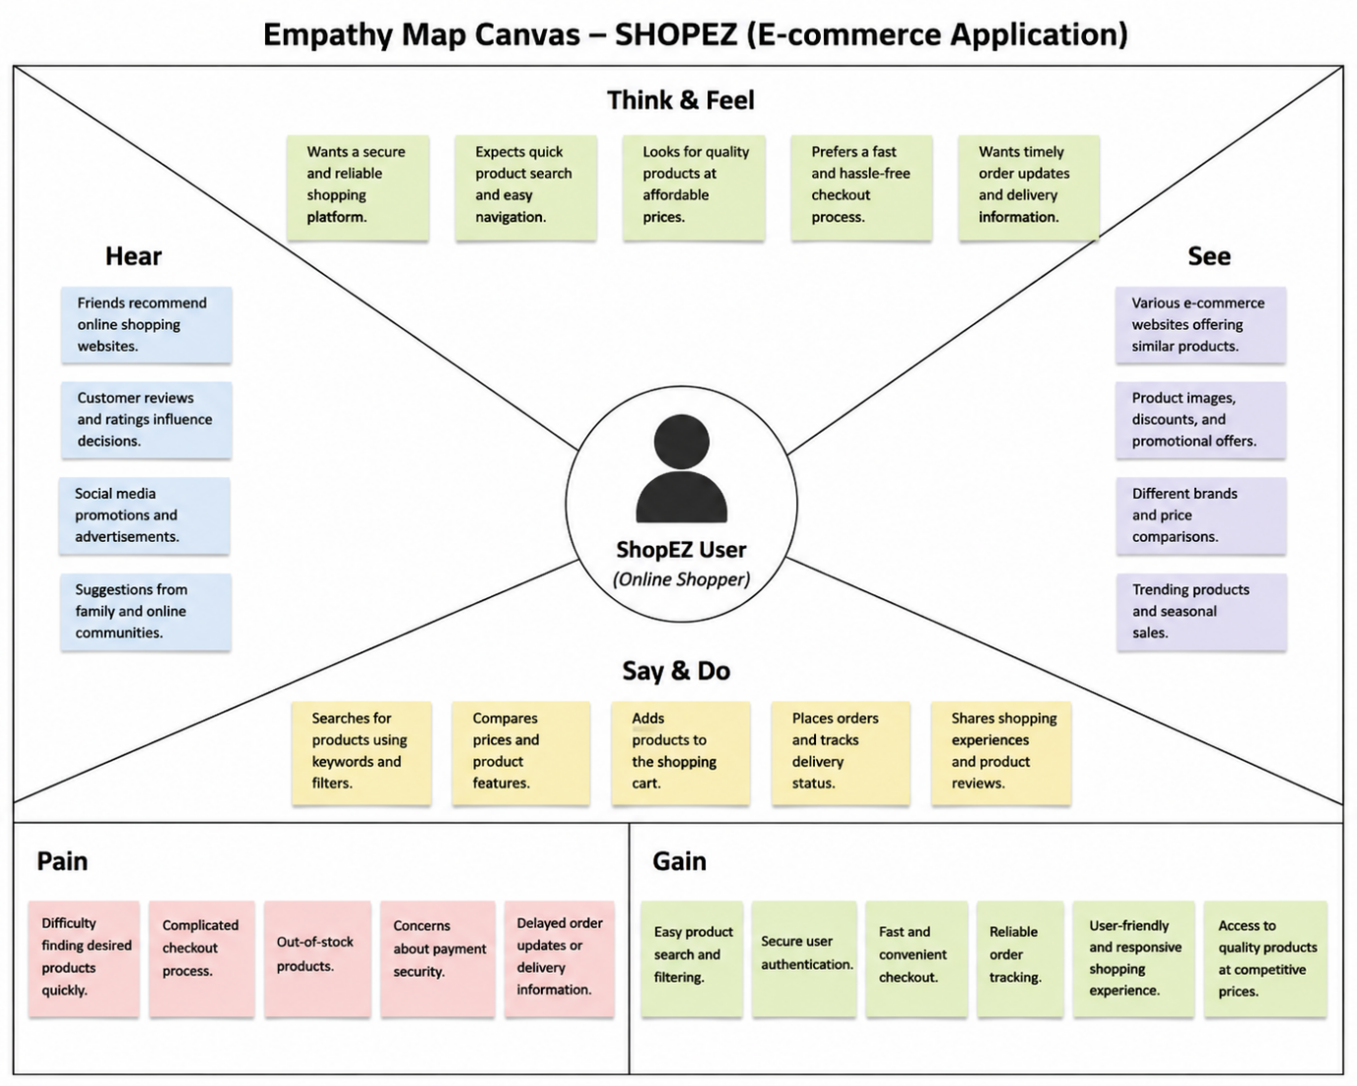
For the ShopEZ – One Stop E-Commerce Platform, the empathy map was created to better understand the expectations of online shoppers and administrators. It helped the team identify user goals, pain points, motivations, and opportunities for improvement. The insights gathered through the empathy map guided the design of features such as secure authentication, easy product search, shopping cart management, smooth checkout, order tracking, and efficient product management, resulting in a user-friendly and reliable shopping experience.

